Jacksonville Youth Football League Inc.
PARENTS / GUARDIANS
“CODE OF CONDUCT”
All parents/guardians who have children participating within the Team must abide by a Code of Conduct, which includes the provisions that follow. Any violation of these rules will result in immediate expulsion from the team. In addition, this forfeits your current membership for the current season and may subject yourself for review for any other subsequent year.
ALL PARENTS/GUARDIANS AGREE TO:
1. I/We agree to furnish proof of Birth - i.e.: Birth Certificate, of applicant to the Association/League/Conference upon request. I/We agree that we will be present at all practice, games and JYFL Events
2. I/We agree to furnish a copy of the most recent school years Report Card to the Association/ League/Conference upon request.
3. I/We agree to be financially responsible for equipment/uniform issued to applicant other than the normal wear and tear during games and practice. Additionally, I/We understand and comprehend I/we will reimburse the League for the loss and/or damage to said equipment.
4. I/We agree to not smoke on the practice or playing field, or in the presence of a gathering of the team/squad. (i.e.: after a game/practice or team/squad meetings.)
5. I/We agree to abstain from the possession and drinking of alcoholic beverages and the possession or use of any illegal substance at any team function. (i.e.: at games/practice, after a game/practice, team/squad meetings or gatherings.) NO ANIMALS ARE ALLOWED ON THE PRACTICE FIELD AND OR GAME FIELD (UNLESS THE ANIMAL IS A CERTIFIED SERVICE ANIMAL WITH PAPERS)
6. I/We agree not to deliberately incite and/or participate in “unsportsmanlike” conduct at ANY team function. This will cause immediate request to leave the premises and wait for your athlete(s) by your vehicle.
7. I/We agree to never protest a game official, judge, or League decision in an aggressive demonstrative manner, which might incite violent or aggressive fan involvement. This will cause immediate request to leave the premises and wait for your athlete(s) by your vehicle.
8. I/We agree not to use abusive or profane language (cursing) or any other uncivil actions at any time at any team function. This will cause immediate request to leave the premises and wait for your athlete(s) by your vehicle.
9. I/We agree not to criticize, belittle, antagonize, berate, or otherwise incite the opposing team, its players, coaches, fans, officials by word of mouth or by gesture. This will cause immediate request to leave the premises and wait for your athlete(s) by your vehicle.
10. I/We agree to accept all decisions of the game officials as being fair and called to the best of their ability. Arguing with any official will be immediate grounds for dismissal from vicinity and wait for athlete(s) by vehicle.
11. I/We agree to treat all children and adults while at any team function with respect.
12. I/We agree to follow the proper Chain of Command when filing a complaint or voicing my opinion regarding any possible rule infraction or concern within my team. All complaints email them to jaxyouthfootballleague@gmail.com
13. I/We understand that we represent JYFL and our athlete(s), we understand that any concerns about officiating and/or coaching during a game must be directed to the League President. I/We also understand that poor behavior from either myself or my guest during games, and/or practice may result in expulsion from the game or practice area, where we will wait next to our car in the parking lot for my child. If this occurs, it may result in expulsion from the league.
14. I/We agree that if we are expelled from the League for inappropriate behavior that we must return all gear immediately back to the league. Understanding this may result in not being allowed back into the league in the future or a specific time frame.
15. I/We agree and understand that once a decision is made by the coach to default on a game by not submitting the roster appropriately will result in default of any games. Doing so will be an acknowledgment by the team and parents of completion of the playing season and all gear/equipment assigned to my athlete(s) MUST be returned within 24hrs.
16. I/We understand that signing my athlete(s) up to play for this league constitutes their playing on assigned games on the season schedule. I/We understand and comprehend signing up to play in the League DOES NOT guarantee my athlete(s) will play or win a Championship or Super Bowl.
17. I/We understand the League is comprised of many teams and not one team is better than the other. I/We understand this League is a family and all teams gather as one. There will be no pinning one team against another. Doing so is a breach of the Code of Conduct of this League.
18. I/We understand that if I/We have any photo’s or media taken from games, please submit them to the league for posting on the League Facebook page and League Website.

The Chain of Command is as follows:
You may only advance to the next level in the chain of command providing your situation has not been handled within 72 hours from your initial filing and you need further assistants.
1. The team Mom and Cheer Coach (If your complaint is regarding the Head Coach you may go directly to the League President.)
2. I/We agree to stay 30 feet back and not to interfere with or come near the football field sideline during the game or practices.
3. I/We agree to take responsibility for any actions that violates this Code of Conduct by a guest or relative of attending parent/guardian.
4. I/We agree not to bring in food, drinks, coolers into the game field.
5. Any act of disrespect from a parent/fan directed towards game officials, coaching staff that is creating a disturbance either in the stands or on the playing field, or has to be ejected from the game, practice or event, by the game official, or Head Coach must leave the area and wait in their vehicle for their player.
6. I/We agree if I/We have been ejected or removed from any event I/We will refrain from attending any practices/games/competitions for the period of my punishment.
I do hereby certify by my signature below as a parent/guardian of a child participating with the Team that I/We have read & received a copy of the Code of Conduct and agree to abide by the terms and conditions of the “CODE OF CONDUCT” set forth by this team. I am also aware that the Team has a ZERO
If at any time you have questions, comments and or concerns – please direct them directly to jaxyouthfootballleague@gmail.com

*** All communications will be passed through the TEAM STACK App.
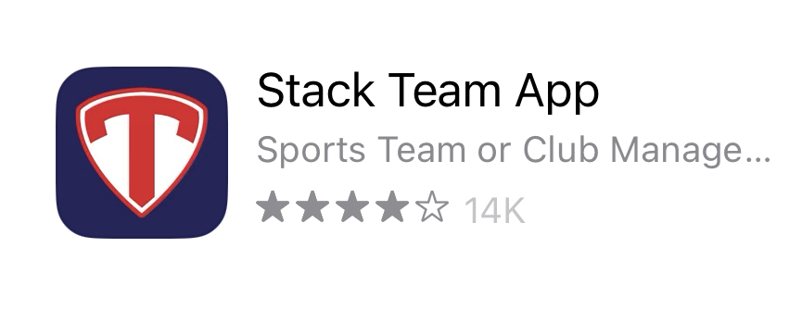
Once you have downloaded the App please let JYFL Board member know.

FLAG (4-6) | $100.00
CHEER (4-13) | $120.00
TACKLE (7-13) | $150.00
GAME DAY ENTRANCE FEE | $5.00 4YO AND UP  3YO AND UNDER FREE
HELMET | $200.00
SHOULDER PADS | $150.00
GAME JERSEY | $150.00
GAME PANTS/PRACTICE PANTS | $100.00
PRACICE JERSEY/GIRDLE/PADS | $100.00

Football is played in the rain - however, the following has to be taken into consideration.

Field Conditions:
The purpose of this section is to guide the use of athletic fields, and to prevent injuries and damage to the playing surface brought upon by inclement weather and/or unsafe playing conditions. An effective field maintenance program is essential for safe, quality fields and sport complexes. Leagues are asked to help by accepting and adhering to these rules. Groups who use the athletic facilities are expected to assist in protecting their participants and fields during periods of rain or inclement weather.

The league reserves the right to cancel and or suspend field use when field conditions could result in injury to players or cause damage to the fields. Usage may also be canceled when the health and safety of participants are threatened due to impending conditions, including but not limited to, rain, muddy conditions, maintenance issues, lightening and hurricanes.
Rain - While a quick rain shower is unlikely to cause much damage, incessant rain can be hazardous. Wet fields, even after the rain has stopped, need to be walked through to verify field conditions for safety.
Playing fields refer to practice and or game fields
Playing fields and turf areas will be deemed unsafe and unplayable when any of the following conditions are present during walk through:
There is standing water within the majority of a single playing field
Your feet suction to the ground as you walk within the majority of a playing field used by Cheer, Flag and or Tackle

Your footprints fill with water in the majority of a playing field.
The depth of your footprint is greater than two inches in the majority of a single playing position.

Grass can be easily dislodged from the fields during play.
Not following the conditions of upkeep of the playing fields during inclement weather outcome:

Forfeiture of future facilities and or field use
Monetary compensation for replacing and or damage to the playing surface

I _____________________(Name) on __________ (Date) Acknowledge receiving, reading and comprehend the Code of Conduct and how it applies to parent(s), guardian(s) and any visiting family and or friends that may come to any function under JYFL. As it will be my responsibility to ensure they “WE” will adhere to the Code of Conduct.
All of the information is located on the JacksonvilleYouthFootballLeague.com webpage. If at any time you have questions, comments and or concerns – please direct them directly to jaxyouthfootballleague@gmail.com
Print Player Name(s) : _____________________________________
_____________________________________
_____________________________________
_____________________________________
_____________________________________

_______________________________________ __________________________________
Print Name and Sign (Parent/Guardian) JYFL Official (Witness)

